Chapter 1

INTRODUCTION

The transfer of energy from a source to a receiver has traditionally necessitated the use of a physical connection. Indeed electrical grids and power outlets span nearly the entire globe and deliver power to billions of people worldwide. Recently there has been much interest into the area of wireless power transfer (WPT) that is the transmission of power without the need for a physical connection or wires. It has gained global acceptance as it is a “hand-free”, “no touch” power transfer system. Recently rapid advancement in power electronics has enabled many new applications of WPT systems like battery charging for electric vehicles, compact electronic devices, mobile phones and medical implants.WPT systems are also very useful for power supplies in harsh environments such as mining, outdoor lightings,etc.The main advantages of wireless power transfer are safety, reliability, low maintenance and long product life. Wireless power transfer techniques fall into two categories known as non-radiative and radiative. In near-field or non-radiative techniques, power is transferred over short distances by magnetic fields using inductive coupling between coils of wire or in a few devices by electric fields using capacitive coupling between electrodes . Conventionally, the inversion stage is chosen as voltage source inverter (VSI) topology or matrix converter or direct AC–AC converter topology .

In VSI topology, the inverter input is stiff voltage. Major limitation of VSI system is components are rated for peak power, very poor coupling between coils and hence high source current cannot be achieved. On the other hand, the current source inverter (CSI) is one in which the dc source has high impedance. Due to large internal impedance, the terminal voltage of the current source inverter (CSI) does not substantially remains constant with a change in load. To overcome the reliability problems in conventional Voltage Source Inverter and Current Source Inverter Z-source inverter is introduced. This provides a unique feature of both buck and boost conversion capability that cannot be obtained in the voltage source inverter and current source inverter. It provides discontinuous input current in the boost mode. The discontinuous current is not permissible for many sources and requires large input filters. To overcome the drawbacks of Z-source inverter, a modified topology known as the quasi Z-source is used for effective power transfer. In this project,Quasi Z-source resonant inverter with double sided LCC compensation for medium power wireless power transfer applications has been designed and implemented.

Chapter 2

LITERATURE SURVEY

The quasi- Z-source inverter (qZSI) has wide applicability in renewable energy systems because it accomplishes a single-stage power conversion with buck-boost characteristics and improves the reliability of the inverter. it improves the profile of the input current and reduces the voltage stress of the capacitor. single-phase quasi-Z-source inverter (qZSI) and a single-phase quasi-switched boost inverter (qSBI), both of which are single-stage buck-boost inverters, are investigated and compared. For the same operating conditions, qSBI has the following advantages over qZSI. three capacitors are saved. the current rating on both of its switches and diodes is lower its boost factor is higher with an equivalent parasitic effect and its efficiency is higher. However, qSBI has one more active switch and one more diode than ZS/qZSIs. In addition, the capacitor voltage stress of qSBI is higher than that of qZSI. The DC and AC component circuit analysis, impedance design with low-frequency and high-frequency ripples, component stresses, and power loss calculation are presented ⁽¹⁾

because the shift of inductors in series with dc source qzsi draw continuous dc input current outclassing ZSI. voltage stress on the capacitor is also reduced in camparison with z –source inverter all of the boost control methods that have been developed for the ZSI can be used by the qZSI.^{(2).} The topologies contain a voltage-fed quasi-Z-source inverter with continuous input current on the primary side, a single-phase isolation transformer, and a voltage doubler rectifier (VDR)^{(3).}

Wireless power transfer (WPT): This technology is of interest especially where the interconnecting wires are inconvenient, or even impossible. Specifically two types of wireless power transfer, radiative and non- radiative, are studied. Additionally the formation of the first standard (Qi) and other standards are mentioned. Finally, the main challenges and future prediction of this technology are presented Over 115 years ago Tesla invented the concept of wireless power transfer. Many industrial applications based on this technology have been developed ever since Wireless power technology offers the chance to remove the cord connections required to connect electronic devices.⁽⁴⁾ Instead of plugging in a mobile phone or laptop via power cord to charge the battery, wireless power can be harnessed and implemented in a home such that a laptop and phone charge continuously and wirelessly without the need for plugging anything in. Higher level applications include charging of electric vehicles (EVs). WPT techniques has been carried in terms of distance, cost, power level, operating frequency, efficiency, and application. From the comparison resonant inductive WPT is better than that of other WPT techniques. However, the design of receiver coil and controlling of transmitter and receiver converters of dynamic charging ⁽⁵⁾

LCC COMPENSATION: double-sided LCC compensation network and its tuning method for wireless power transfer (WPT). the proposed topology and its tuning method, the resonant frequency is irrelevant with the coupling coefficient between the two coils and is also independent of the load condition, which means that the system can work at a constant switching frequency. Nearly unit power factors can be achieved for both the primary-side and secondary-side converters in the whole range of coupling and load conditions; thus, high efficiency for the overall WPT system is easily achieved ⁽⁶⁾

MUTUAL INDUCTANCE: Unlike transformer coils that are wound around a magnetic core to attain tight coupling, the contactless coils are usually loosely coupled due to the absence of common magnetic core. The magnetic coupling between the primary and secondary side depends on mutual inductance (MI) between the coils⁽⁶⁾
VOLTAGE DOUBLER : are also called as voltage multiper, a electronic circuit which charges capacitors from the input voltage and switches these charges in such a way that, in the ideal case, exactly twice the voltage is produced at the output as at its input. Because voltage multipliers do not require inductors only capacitors and rectifying devices. rectifier which take an AC voltage as input and outputs a doubled DC voltage ^{(9).}

EXISTING SYSTEM

3.1.BLOCK DIAGRAM

Inverter
AC Source
Transmission Coil
Receiver Coil
Load

Figure3.1Block diagram of Z-Source WPT system

The AC supply is given to the Z source inverter. The voltage across the inverter bridge is boosted and the power flows from the Z-source network and inverter to the resonant wireless power transformer and then to the load.

3.2.CIRCUIT DIAGRAM
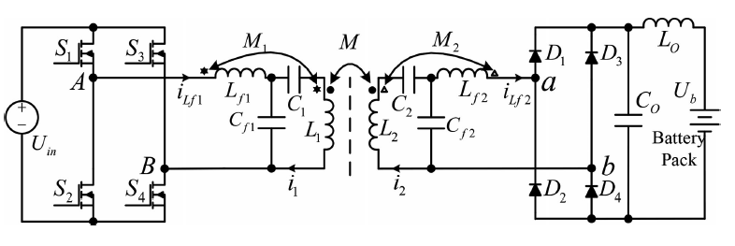

Figure:3.2Circuit diagram of z-source inverter WPT system

The Z-source network consisting of inductors L₁₁, L₂₂ and capacitors C₁₁, C₂₂ are connected to the rectified dc output of a three phase ac voltage source. In the existing circuit, at first three phase ac voltage V_{ac}(phase voltage) is rectified into dc voltage V_{dc} by a diode bridge rectifier. This dc link voltage serves as the dc input voltage to the Z-source network. The dc output voltage V_{i} of the Z-source network is converted into a high frequency single phase ac voltage by an IGBTs-based full-bridge resonant inverter for WPT system. In this WPT system series-parallel (SP) compensation topology has been used .

3.2.1WORKING

During the active state switch S₁ is ON and switch S₂ is OFF. During this state capacitors are charged from rectified DC voltage and inductor. The voltage across the inverter bridge is boosted and the power flows from the Z-source network and inverter to the resonant wireless power transformer and then to the load. In boost mode, three switches in the inverter bridge are ON and the remaining one can be either ON or OFF. The power is transferred from the capacitors to the inductors and then the dc link voltage across the input of the inverter is boosted. During this boost mode, the conventional zero state is converted to shoot-through zero state. In this way, the sinusoidal output current is maintained and the voltage boost is achieved.

3.3. ADVANTAGES OF EXISTING SYSTEM

- Operates in both buck and boost mode.
- Invulnerable to EMI noises.
- Increased reliability than conventional VSI and CSI systems.

3.4. DISADAVANTAGES OF EXISTING SYSTEM

- Discontinuous input current in boost mode.

- Capacitor in the impedance must sustain high voltage.

- The usage of high filters resulting in increased number of components.

- Decreased efficiency of 69.68%.

- High source stress starting from 22.27W.

- Exhibits control difficulty and increased cost.

- High component ratings.

- Complicated control strategies.

Chapter 4

PROPOSED SYSTEM

4.1.BLOCK DIAGRAM

T
R
RE
QUASI Z SOURCE
FULL BRIDGE HIGH FREGUENCY INVERTER
LCC
VOLTAGE
DOUBLER
L
C
C

DC
LOAD
GATE DRIVER
AMPLIFIER
5V
5V

MICROCONTROLLER

Figure 4.1 Block diagram of Quasi Z-source inverter with double sided LCC compensation

The DC supply given to the Quasi Z-Source Inverter gets transmitted from the primary coil to the receiver coil and get doubled using voltage doubler then given to the load. The inverter switch is triggered by a control circuit which includes microcontroller, amplifier and gate driver .

4.2.CIRCUIT DIAGRAM
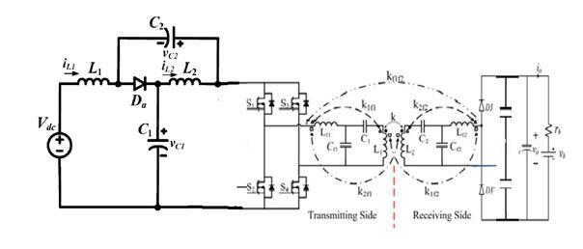

Figure:4.2 Quasi z-source inverter WPT system

The voltage V_{DC} is supplied to the quasi z-source which consists of two inductors L₁ and L₂,two capacitors C₁ and C₂ and a diode D_{a}. From this a continuous current is supplied to the inverter which includes four MOSFET switches S₁,S₂,S₃,S₄ and four diodes D₁,D₂,D₃,D₄.The DC voltage thus gets converted to AC voltage and pass through LCC compensation of transmitted side .The transmitted voltage is received by LCC compensation of receiver side and made to flow through diode D₅,D₆ and two capacitors which constitute voltage doubler circuit and gets stored in V_{b} is supplied to the load.
S1 ∼ S4 Primary-side MOSFETs. D1 ∼ D4 Secondary-side rectifier diodes. L1 Self-inductance of the transmitting coil. Lf1 Primary-side compensation inductance. L2 Self-inductance of the receiving coil. Lf2 Secondary-side compensation inductance. Ls1 Leakage inductance of the transmitting coil. Ls2 Leakage inductance of the receiving coil.

4.2.1.QUASI Z-SOURCE
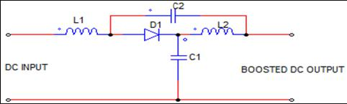

Figure4.3 Circuit diagram of Quasi Z-source

Quasi Z-Source has internal impedance network that connects the converter main circuit to the power source or load. The quasi Z- source inverter consists of two inductors L1 and L2 and two capacitors C1 and C2.The inductor present in the quasi Z-source inverter reduces the source current. The capacitor voltage is lower than in case of Z- source inverter. The quasi Z-source network connected the converter to the dc source and load. The dc source can be a battery, fuel cell, photovoltaic cell and load can be inductor, capacitor, resistor or a combination of these. The low voltage stress is obtained on the capacitors. There are nine switching states including six effective states, two additional zero states and one direct zero state. The direct zero state and traditional zero state will not affect output voltage. In the active state, only one device conducts in each phase leg.

4.3.WORKING

The 12V DC supply is given to the quasi Z-source inverter. The unique LC and diode network connected to the inverter bridge allow the shoot through state of quasi Z-source by protecting the circuit from damage. In QUASI, the operation involves in three modes containing active state mode, zero state mode and shoot through mode. It has two active states, two traditional zero states and three shoot through zero states.

Table 4.1 Operating states of QUASI

STATE | S₁ | S₂ | S₃ | S₄
Active state | ON | OFF | ON | OFF
 | OFF | ON | OFF | ON
Traditional | ON | ON | OFF | OFF
zero state
 | OFF | OFF | ON | ON
Shoot through | ON | OFF | OFF | ON
zero state
 | OFF | ON | ON | OFF
 | ON | ON | ON | ON

When supply is given to the microcontroller it generates pulse with low current gain which is increased by amplifier and given to the gate driver which is used to trigger the MOSFET. The switches S₁,S₂,S₃ and S4 are unidirectional, i.e. they conduct current in one direction.

When the switches S₁ and S₂ are turned on simultaneously for a duration 0 ≤ t ≤ T₁ ,the the input voltage V_{in} appears across the load. If the switches S₃ and S₄ turned on duration T1 ≤ t ≤ T2,the voltage across the load the load is reversed. The AC output voltage of the inverter is made to pass through LCC compensation. The transmitter side LCC leads to zero current switching thereby reducing the switching losses. It also performs wave shaping. In receiver section the reactive power is compensated through LCC compensation. The voltage doubler consisting of two diodes and two capacitors is designed to twice the value of input AC voltage into DC voltage.

4.4.ADVANTAGES

- Quasi Z-source inverter work as buck-boost inverter.

- Reduced source stress.

- The source can either be a voltage source or current source. The load can either be inductive or capacitive or another z-source network.

- Additional boosting of voltage.

- High effectiveness.

- More reliable.

- Heavy and expensive step-up transformers can be replaced in some applications by voltage doubler.

4.5. APPLICATIONS

- Electric vehicle applications

- Electronic portable device
- Cell phones

Chapter 5

HARDWARE SPECIFICATIONS

5.1. DC SOURCE

DC is the unidirectional flow of electric charge. A battery is a good example of DC power supply. Direct current may flow in a conductor through wires or through semi conductors.
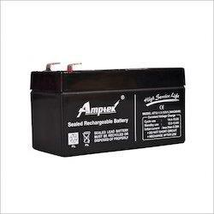
Table 5.1Battery rating
Model number | AT12-1.3
Voltage | 12V
Power | 1.3AH
Weight | 0.57kg
Dimensions | 97*43*52mm
 |  | Figure 5.1battery

DC current can also be generated by means of other than batteries. Solar cells, fuel cells and even some types of generators can provide DC current. Step down transformer connected with a rectifier can also be also used as a DC source. Direct current is used to charge batteries and as power supply for electronic systems. DC is commonly found in many extra low voltage applications and some low voltage applications, especially where these are powered by batteries or solar systems (since both can produce only DC).Most electronic circuits require a DC power supply.

5.2.QUASI Z-SOURCE

The quasi z-source inverter circuit differs from the conventional z-source inverter in LC impedance network interface between the source and inverter. The reliability, reduced source stress are the advantages of quasi z-source inverter.
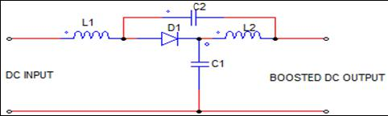

Figure 5.2.Circuit diagram of quasi z source

The circuit involves impedance network having inductances L₁,L₂ and capacitances C₁,C₂ and the inverter module contains IGBT switches with an anti parallel diodes. In QUASI, the operation involves in three modes including active state mode,zero state mode and shoot through mode.It has two active states,two traditional zero states and three shoot through zero states.

Active states: One of the upper switches and one of the lower switches of different legs are turned on and power flow to load.
Traditional Zero states: Upper or lower two switches are turned on and power
does not flow to load.Shoot through states: The switches of same leg.

5.3.MOSFET[8A, 500V, 0.850 Ohm]

The N-Channel enhancement mode silicon gate power field effect transistor is advanced powers MOSFET designed, tested and guaranteed to withstand a specified level of energy in the breakdown avalanche mode of operation. It possess linear transfer characteristics and high input impedance. All of these power MOSFETs are designed for applications such as switching regulators, switching converters, motor drivers, relay drivers and drivers for high power bipolar switching transistors requiring high speed and low gate drive power. These types can be operated directly from integrated circuits. Enhancement-mode MOSFETs are the common switching elements in most MOS. These devices are off at zero gate–source voltage NMOS can be turned on by pulling the gate voltage higher than the source voltage while PMOS can be turned on by pulling the gate voltage lower than the source voltage. In most circuits, this means pulling an enhancement-mode MOSFETs gate voltage towards its drain voltage turns it ON.
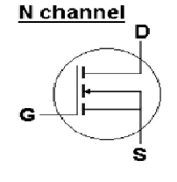
Figure 5.3 Enhanchement n channel MOSFET

5.4.MICROCONTROLLER[PIC16F877A-I/P]

The PIC16F877A features 256 bytes of EEPROM data memory, self programming, and ICD,2 comparators,8 channels of 10 bit A/D converter, synchronous serial port can be configured as either 3 wires SPI are 2 wire I2C bus and a USART.It is ideal for advanced level A/D applications in automotive, industrial, appliances and consumer applications.
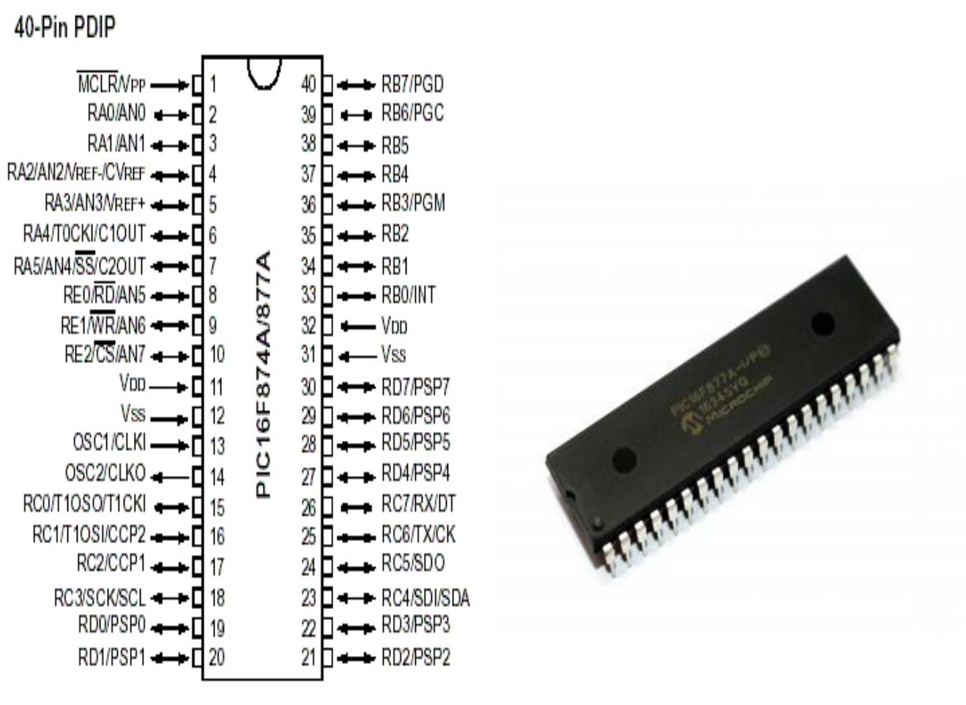

Figure 5.4 PIC Microcontroller

5.5.AMPLIFIER[KS74AHCT244N]

An amplifier is a circuit that has a power gain greater than one. An amplifier uses electric power from a power supply to increase the amplitude of a signal. Typically a current buffer amplifier is used to transfer a current from a first circuit having a low output impedance level to a second circuit with a high input impedance level. The interposed buffer amplifier prevents the second circuit from loading the first circuit unacceptably and interfering with its desired operation. In the ideal current buffer the input impedance is zero and the output impedance is infinite (impedance of an ideal current source is infinite).Properties of the ideal buffer are: perfect linearity, regardless of signal amplitudes; and instant output response, regardless of the speed of the input signal. Most amplifiers are designed to be linear.
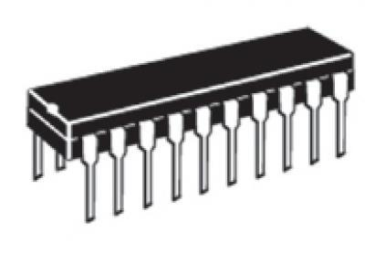

Figure 5.5 Amplifier

5.6.GATE DRIVER[FAN 7392N]

A gate driver is a power amplifier that accepts a low-power input from a controller IC and produces a high-current drive input for the gate of a high-power transistor such as an IGBT or power MOSFET. Gate drivers can be provided either on-chip or as a discrete module. In essence, a gate driver consists of a level shifter in combination with an amplifier. A gate driver is used when a pulse-width-modulation (PWM) controller cannot provide the output current required to drive the gate capacitance of the associated MOSFET. Gate
drivers may be implemented as dedicated ICs,discrete transistors or transformers.They can also be integrated within a controller IC.One gate driver is used to drive two MOSFETs.
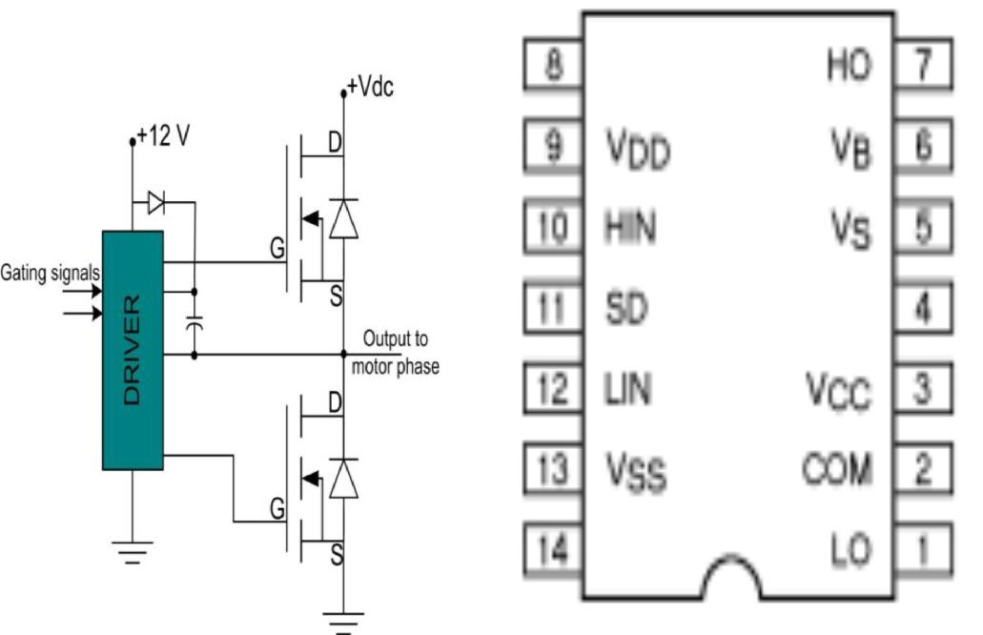

Figure 5.6 Gate driver

5.8.VOLTAGE DOUBLER

A voltage doubler is an electronic circuit which charges capacitors from the input voltage and produces twice the given input at the output.The simplest of these circuits are a form of rectifier which takes an AC voltage as input and outputs a doubled DC voltage.The switching elements are simple diodes and they are driven to switch state by the alternating voltage of the input.DC-to-DC voltage doubler cannot switch in this way and requires a driving circuit to control the switching. They frequently also require a switching element that can be controlled directly by transistor.Voltage doublers are a variety of voltage multiplier circuit.Voltage doubler circuits can be viewed as a single stage of a higher order multiplier and by cascading identical stages together achieves a greater voltage multiplication.
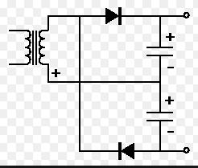

Figure 5.9 Circuit diagram of Voltage doubler

In this circuit each of the two peak detector cells operates on opposite half-cycles of the incoming waveform. Since their outputs are in series, the output is twice the peak input voltage.

Chapter 6

SOFTWARE SPECIFICATIONS

6.1.MATLAB

MATLAB is a high-performance language for technical computing. It integrates computation, visualization, and programming in an easy-to-use environment where problems and solutions are expressed in familiar mathematical notation.Typical uses includes

- Math and computation

- Algorithm development

- Data acquisition

- Modeling, simulation, and prototyping

- Data analysis, exploration, and visualization

- Scientific and engineering graphics

- Application development, including graphical user interface building

MATLAB is an interactive system whose basic data element is an array that does not require dimensioning.This solves many technical computing problems, especially those with matrix and vector formulations, in a fraction of the time it would take to write a program in a scalar non interactive language such as C or Fortran.

6.1.1Building the Electrical Circuit with powerlib Library:

The graphical user interface makes use of the Simulink functionality to interconnect various electrical components.The electrical components are grouped in a library called powerlib.

1.Open the SimPower Systems library by entering the following command at the MATLAB prompt.

This command displays a Simulink window showing icons of different block libraries.
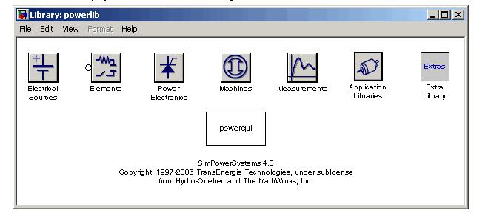

Figure 6.1 Powerlib library

You can open these libraries to produce the windows containing the blocks to be copied into your circuit.Each component is represented by a special icon having one or several inputs and outputs corresponding to the different terminals of the component.

2.From the File menu of the powerlib window,open a new window to contain your first circuit and save it as circuit1.

3.Open the Electrical Sources library and copy the AC Voltage Source block into the circuit1 window. C components have disappeared so that the icon now shows a single resistor.

6.1.2.Interfacing the Electrical Circuit with Simulink:

The Voltage Measurement block acts as an interface between the SimPower Systems blocks and the Simulink blocks. For the system shown above, you implemented such an interface from the electrical system to the Simulink system. The Voltage Measuremenst block converts the measured voltages into Simulink signals.Similarly, the Current Measurement block from the Measurements library of powerlib can be used to convert any measured current into a Simulink signal.

6.2.SIMULATION DIAGRAM

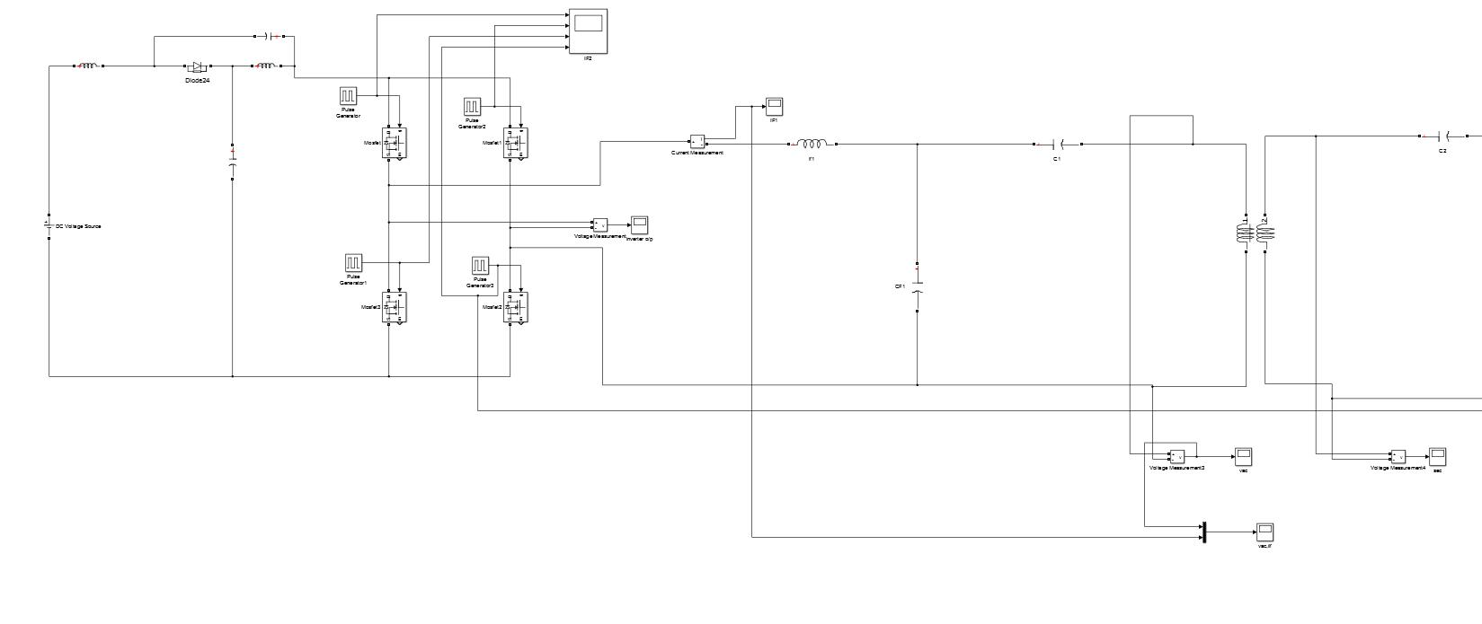

Figure 6.2 TRANSMITTING SIDE

RECEIVER SIDE

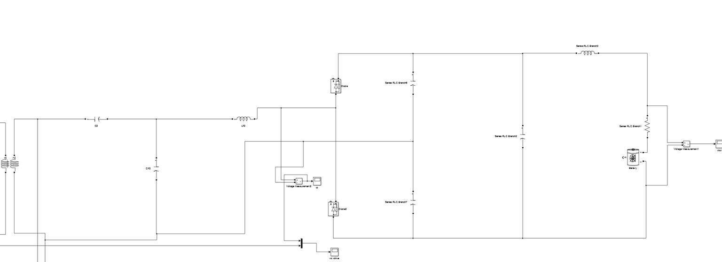

Figure 6.3

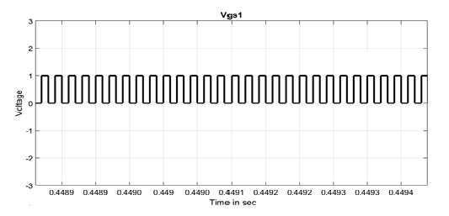
Figure6.4MOSFET
The above waveform shows the gate source voltage of MOSFET
The waveform is the output of the MOSFET switches.It is drawn between voltage and time in sec.

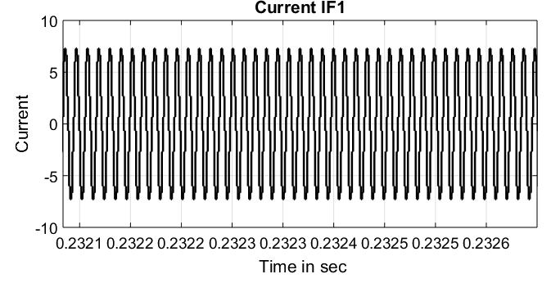

Figure6.5currentIF1

The above waveform shows the output current of the voltage doubler.It is drawn between the current and time in sec.

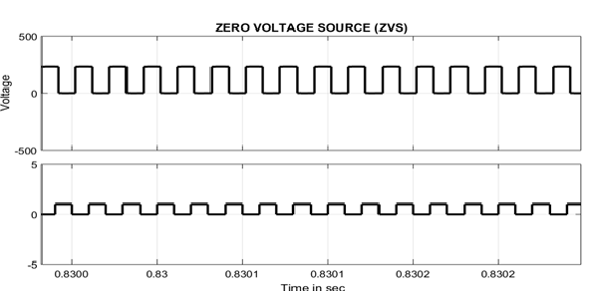

Figure6.5 zero voltage source

The above waveform shows the zero output voltage.It is plotted between voltage and Time in sec.

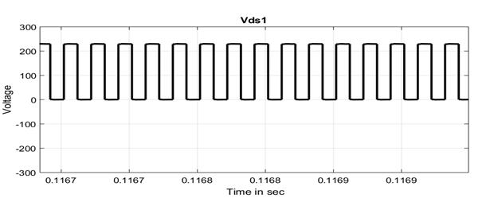

Figure6.6 vds1

The above waveform shows the output of the drain source voltage, which is obtained from drain in the mosfet. The waveform is plotted between voltage and time in sec.

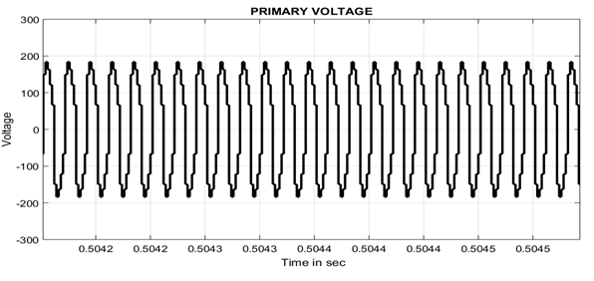 Figure6.7primary voltage

The above waveform shows the primary voltage which is obtained from the transmitter side.the waveform is plotted between voltage and time in sec.

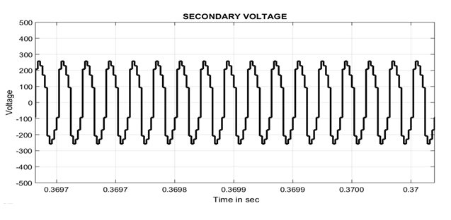 Figure6.8 secoundary voltage
The waveform shows the output voltage of the secounday side. which is obtained through coils.The waveform is plotted between voltage and time in sec
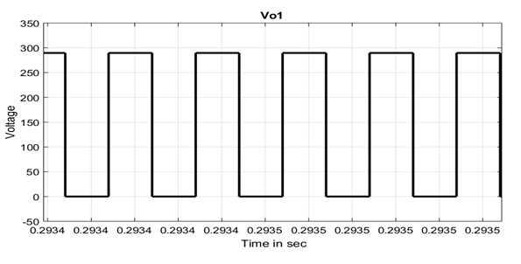 Figure6.9 v01

The above waveform shows the output voltage of v01.It is plotted between voltage and time in sec

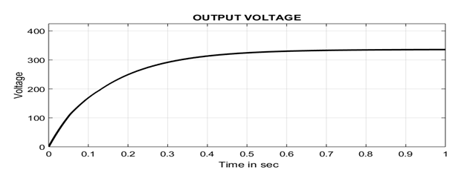
Figure6.10 output voltage

The above waveform shows the output voltage.in which the plot is drawn between the voltage and time in sec

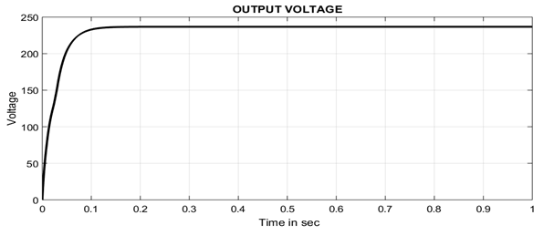
Figure6.11 output voltage

The above waveform shows the output voltage.in which the plot is drawn between the voltage and time in sec

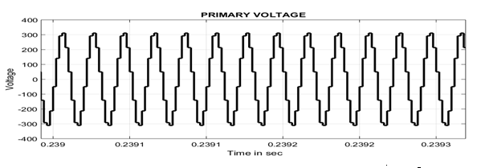
Figure6.12 primary voltage

The waveform shows the output voltage of the secondary side. which is obtained through coils. The waveform is plotted between voltage and time in sec

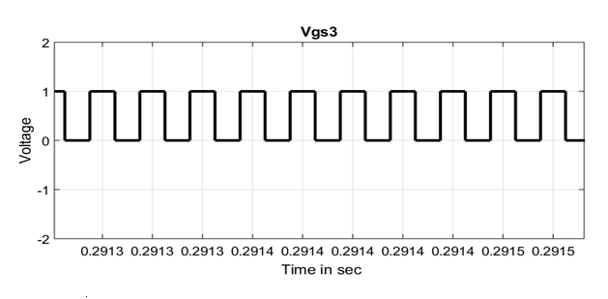 Figure6.13vgs3

The above waveform shows the gate source voltage of mosfet.The waveform is plotted for the voltage and time in sec.

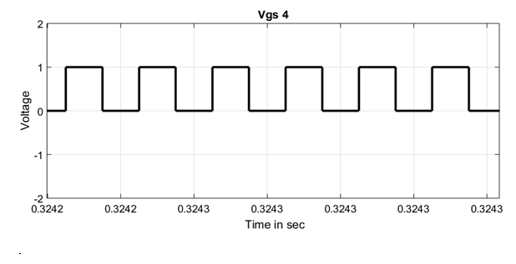 Figure6.14Vgs4
The above waveform shows the gate source voltage of mosfet3.The waveform is plotted for the voltage and time in sec.

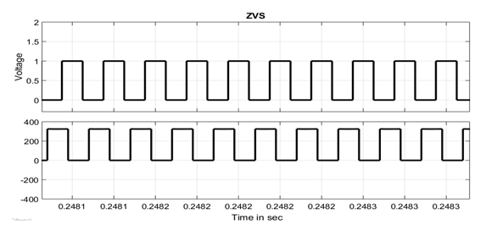
Figure6.15 ZVS

The above waveform shows the zero output voltage.It is plotted between voltage and Time in sec.

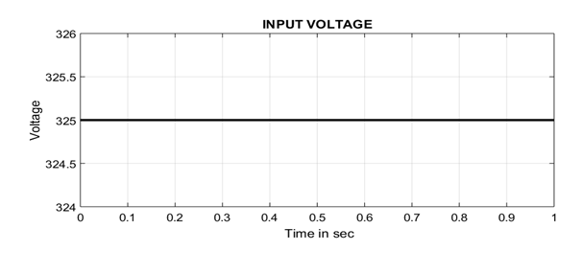 Figure6.16 input voltage
The above waveform shows the input voltage.It is plotted between voltage and Time in sec.

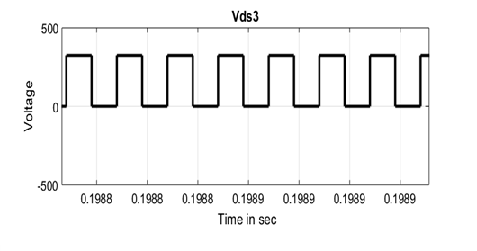
Figure6.17 Vds3
The above waveform shows the gate source voltage of mosfet3.The waveform is plotted for the voltage and time in sec.

Chapter 7

RESULT

Proposed system with LED glowing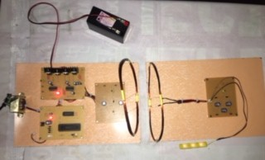

1.Electrical Energy is transferred through the coils and the LED light glows
thus the electric energy is transferred without wires.
2.Similarly we can use this system in motors applications, EV_ VECHILE Application.

WORKING

When 12 v dc supply is given to the microcontroller then it generates pulse,then a 5v supply is given to the gate driver,to drive the mosfet.Then from the transmitter side energy is supplied to the receiver side then the led glow

Chapter 8
CONCLUSION

A new inductive WPT circuit using quasi z-source topology with double sided LCC compensation is studied and analyzed. It is suitable for solar-to vehicle, opportunistic charging, and single-phase residential slow charging. This topology provides an alternative WPT solution for EV charging. The topology achieves soft-switching of all semiconductor devices with reduced source stress. Hardware implementation of the proposed system is performed and is simulated using MATLAB-R2015A.The maximum efficiency of complete DC– DC stage is around 80% with the distance of 12cm and 3cm misalignment. The source stress is reduced and continuous current supply is achieved. Double sided LCC compensation results in zero current switching and reactive power compensation thereby reducing the switching losses. By using RV-IGBTs increased distance can be achieved in future works.

REFERENCES

[1]. A Comparison Between Single-Phase Quasi-ZSource and Quasi-Switched-Boost InvertersMinh-Khai Nguyen, Member, IEEE, Young-Cheol Lim, Member, IEEE, and Sung-Jun Park

2.. Quasi-Z-Source Inverter for Photovoltaic Power Generation Systems Yuan Li1,2, Joel Anderson2 , Fang Z. Peng2 , and Dichen Liu1 1. Dept. of Electrical Engineering, Wuhan University, Hubei 430072, China 2. Dept. of Electrical and Computer Engineering, Michigan State University, East Lansing, MI 48824, USA

3 Quasi-Z-Source-Based Isolated DC/DC Converters for Distributed Power Generation Dmitri Vinnikov, Member, IEEE, and Indrek Roasto

4. A Literature Survey of Wireless Power Transfer Reem Shadid, Sima Noghanian, and Arash Nejadpak Department of Electrical Engineering, University of North Dakota reem.shadid@und.edu, sima.noghanian@engr.und.edu, arash.nejadpak@engr.und.edu

5 Wireless Power Transfer Technologies for Electric Vehicle Battery Charging – A State Of The Art Dharavath Kishan Research Scholar Dept. of EEE National Institute of Technology, Trichy, Tamilnadu, India. dharavathkishan4@gmail.com P Srinivasa Rao Nayak Asst. Professor Dept. of EEE National Institute of Technology, Trichy, Tamilnadu, India. psnayak@nitt.edu

6. A Double-Sided LCC Compensation Network and Its Tuning Method for Wireless Power Transfer Siqi Li, Member, IEEE, Weihan Li, Student Member, IEEE, Junjun Deng, Student Member, IEEE, Trong Duy Nguyen, Member, IEEE, and Chunting Chris Mi, Fellow, IEE

7. Mutual Inductance Computation Method for Coils of Different Geometries and Misalignments Ankit Dalal, T.P. Ezhil Reena Joy and Praveen Kumar Department of Electronics and Electrical Engineering Indian Institute of Technology Guwahati Guwahati - 781039, Assam, India Email: {d.ankit, ezhil, praveen kumar}@iitg.ernet.i.

8. An Analytical Model of AC-DC Voltage Multipliers Toru Tanzawa, Micron Japan, Ltd., 5-37-1, Kamata, Ota-ku, 144-8721 Tokyo, Japan, email: ttanzawa@micron.com

9. LLC Resonant High-voltage DC-DC Converter with Voltage Multiplier Rectifier Nor Azura Samsudin, Shahid Iqbal, Soib Taib School of Electrical and Electronics Engineering, Universiti Sains Malaysia,13400 Nibong Tebal, Pulau Pinang, Malaysia norazura200584@gmail.com, shahidsidu@hotmail.com, soibtaib@usm.

10.Prof. Ravi Gupta, Sapna Teotia International Journal of Electronics, Electrical and Computational System IJEECS ISSN 2348-117X Volume 4, Special Issue May 2015

